Program of half subtractor:

library IEEE;

use IEEE.STD_LOGIC_1164.ALL;

use IEEE.STD_LOGIC_ARITH.ALL;

use IEEE.STD_LOGIC_UNSIGNED.ALL;

entity half_sub is

port( A, B : in std_logic;

DIFF, Borrow : out std_logic);

end entity;

architecture dataflow of half_sub is

begin

DIFF <= A xor B;

Borrow <= (not A) and B;

end architecture;

OUTPUT:

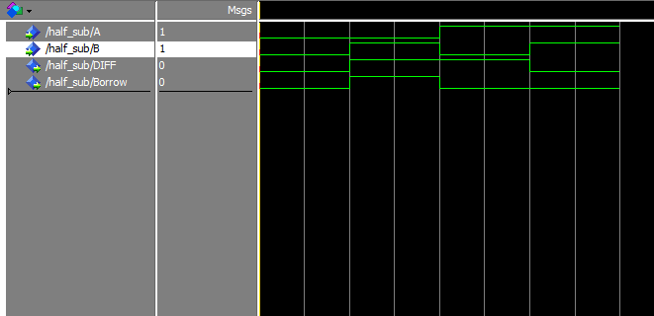

Program of full subtractor:

library IEEE;

use IEEE.STD_LOGIC_1164.ALL;

use IEEE.STD_LOGIC_ARITH.ALL;

use IEEE.STD_LOGIC_UNSIGNED.ALL;

entity full_sub is

port( A, B, C: in std_logic;

DIFF, Borrow : out std_logic);

end entity;

architecture dataflow of full_sub is

begin

DIFF <= (A xor B) xor C;

Borrow <= ((not A) and (B or C)) or (B and C);

end dataflow;

OUTPUT:

